|  |  |  |  |  |  |  |  |  |  |  |  |  |  |  |  |  |  |  |  |  |  |  |  |  |  |  |  |  |  |  |  |  |  |  |  |  |  |  |  |  |  |  |  |  |  |  |  |  |  |  |  |  |  |  |  |  |  |  |  |  |  |  |  |  |  |  |  |  |  |  |  |  |  |  |  |  |  |  |  |  |  |  |  |  |  |  |  |  |  |  |  |  |  |  |  |  |  |  |  |  |  |  |  |  |  |  |  |  |  |  |  |  |  |  |  |  |  |  |  |  |  |  |  |  |  |  |  |  |  |  |  |  |  |  |  |  |  |  |  |  |  |  |  |  |  |  |  |  |  |  |  |
| --- | --- | --- | --- | --- | --- | --- | --- | --- | --- | --- | --- | --- | --- | --- | --- | --- | --- | --- | --- | --- | --- | --- | --- | --- | --- | --- | --- | --- | --- | --- | --- | --- | --- | --- | --- | --- | --- | --- | --- | --- | --- | --- | --- | --- | --- | --- | --- | --- | --- | --- | --- | --- | --- | --- | --- | --- | --- | --- | --- | --- | --- | --- | --- | --- | --- | --- | --- | --- | --- | --- | --- | --- | --- | --- | --- | --- | --- | --- | --- | --- | --- | --- | --- | --- | --- | --- | --- | --- | --- | --- | --- | --- | --- | --- | --- | --- | --- | --- | --- | --- | --- | --- | --- | --- | --- | --- | --- | --- | --- | --- | --- | --- | --- | --- | --- | --- | --- | --- | --- | --- | --- | --- | --- | --- | --- | --- | --- | --- | --- | --- | --- | --- | --- | --- | --- | --- | --- | --- | --- | --- | --- | --- | --- | --- | --- | --- | --- | --- | --- | --- | --- |
| **Ficha de Inscrição – Workshop Hip Hop** | | | | | | | | | | | | | | | | | | | | | | | | | | | | | | | | | | | | | | | | | | | | | | | | | | | | | | | | | | | | | | | | | | | | | | | | | | | | | | | | | | | | | | | | | | | | | | | | | | | | | | | | | | | | | | | | | | | | | | | | | | | | | | | | | | | | | | | | | | | | | | | | | | | | | | | |
|  | |  | | | | |  | | |  | | |  | | |  | | | | |  | |  | | |  | | |  | | |  | | |  | | |  | | | |  | | |  | | | |  | | |  | | |  | | |  | | |  | | | |  | | |  | | |  | | |  | | |  | | |  | | |  | | |  | | |  | | |  | | | |  | | | |  | | |  | | | |  | | | |  | | | |  | | | |  | | |  | | |  | | | | |  | |  | | |  | |  | | |  | | | | |  | | | |  |  | | |  | | | |
| **Nome:** | | | | | | | | | |  | | |  | | | | | | | | | | | | | | | | | | | | | | | | | | | | | | | | | | | | | | | | | | | | | | | | | | | | | | | | | | | | | | | | | | | | | | | | | | | | | | | | | | | | | | | | | | | |  | | | **Nº Sócio:** | | | | | | | | |  | | | | | | | | | | | | | | | **Não Sócio:** | | | | | | | | | | | | | | | | |  | | |  | | |
|  | |  | | | | |  | | |  | | |  | | |  | | | | |  | |  | | |  | | |  | | |  | | |  | | |  | | | |  | | |  | | | |  | | |  | | |  | | |  | | |  | | | |  | | |  | | |  | | |  | | |  | | |  | | |  | | |  | | |  | | |  | | | |  | | | |  | | |  | | | |  | | | |  | | | |  | | |  | | | |  | | |  | | | | |  | |  | | |  | |  | | |  | | | | |  | | | |  |  | | |  | | | | |
| **Outros participantes:** | | | | | | | | | | | | | | | | | | | | | | | | | | | | | | | | | | | | | | | | | | | | |  | | | |  | | |  | | |  | | |  | | |  | | | |  | | |  | | |  | | |  | | |  | | |  | | |  | | |  | | |  | | |  | | | | | | | | | | |  | | | |  | | | |  | | | |  | | |  | | | |  | | |  | | | | |  | |  | | |  | |  | | |  | | | | |  | | | |  |  | | |  | | | | |
|  | | | | | | | | | | | | | | | | | | | | | | | | | | | | | | | | | | | | | | | | | | | | | | | | | | | | | | | | | | | | | | | | | | | | | | | | | | | | | | | | | | | | | | | | | | | | | | | | | | |  | | | | |  | | | | **Nº Sócio:** | | | | |  | | | | | | | | | | | | | | | **Não Sócio:** | | | | | | | | | | | | | | | | |  | | |  | | |
|  |  | | | | |  | | |  | | |  | | |  | | | |  | | |  | | |  | | |  | | |  | | |  | | |  | | | |  | | |  | | | |  | | |  | | |  | | |  | | |  | | | |  | | |  | |  | | |  | | |  | | |  | | |  | | |  | | |  | | |  | | | |  | | | | |  | | |  | | | |  | | | |  | | | | | | | | | |  | | |  | | |  | |  | | | | |  | |  | | |  | | |  | |  | | |  | | |  |  | | |  | | | | |
|  | | | | | | | | | | | | | | | | | | | | | | | | | | | | | | | | | | | | | | | | | | | | | | | | | | | | | | | | | | | | | | | | | | | | | | | | | | | | | | | | | | | | | | | | | | | | | | | | |  | | | |  | | | | **Nº Sócio:** | | | | | |  | | | | | | | | | | | | | | | **Não Sócio:** | | | | | | | | | | | | | | | | | |  | | |
|  | | |  | | | | |  | | |  | | |  | | |  | | |  | | | |  | | |  | | |  | | |  | | |  | | |  | | | |  | | | |  | | |  | | |  | | |  | | |  | | | |  | | |  | | | |  | | |  | | |  | | |  | | |  | | |  | | |  | | | | |  | |  | | | | | |  | | |  | | | | |  | | | |  |  | | | | | | |  | | |  | | |  | |  | | | | |  | |  | | |  | | |  | |  | | |  | |  |  | | | |  | | | |
| **Assinale as opções pretendidas:** | | | | | | | | | | | | | | | | | | | | | | | | | | | | | | | | | | | | | | | |  | | | | | | **Pretendo participar no Workshop** | | | | | | | | | | | | | | | | | | | | | | | | | | | | | | | | | | | | | | | | | | | | | | |  | | | |  | | | |  | | |  | | | | |  | | | | **Pretendo participar nas aulas de dança** | | | | | | | | | | | | | | | | | | | | | | | | | | | | | | | | | | |  | | |  | | |  | | | |
|  | | |  | | | | |  | | |  | | |  | | |  | | |  | | | |  | | |  | | |  | | |  | | |  | | |  | | | |  | | | |  | | |  | | |  | | |  | | |  | | | |  | | |  | | | |  | | |  | | |  | | |  | | |  | | |  | | |  | | | | |  | |  | | | | | |  | | |  | | | | |  | | | |  |  | | | | | | |  | | |  | | |  | |  | | | | |  | |  | | |  | | |  | |  | | |  | |  |  | | | |  | | | |
| **Pagamento das aulas de dança:** | | | | | | | | | | | | | | | | | | | | | | | | | | | | | | | | | | | | | | | **Vencimento:** | | | | | | | | | | | | | | | | | | | | | | |  | | | |  | | | |  | | | **Numerário:** | | | | | | | | | | | | | | | | | |  | | | | | | |  | | | | | | **Transf. Bancária (0035.21790001079833036):** | | | | | | | | | | | | | | | | | | | | | | | | | | | | | | | | | | | | | | | | | | | |  | | |  | | |  | | | |
|  | | |  | | | | |  | | |  | | |  | | |  | | |  | | | |  | | |  | | |  | | |  | | |  | | |  | | | |  | | | |  | | |  | | |  | | |  | | |  | | | |  | | |  | | | |  | | |  | | |  | | |  | | |  | | |  | | |  | | | | |  | |  | | | | | |  | | |  | | | | |  | | | |  |  | | | | | | |  | | |  | | |  | |  | | | | |  | |  | | |  | | |  | |  | | |  | |  |  | | | |  | | | |
| **Assinatura:** | | | | | | | | | | | | | | | | | |  | | | | | | | | | | | | | | | | | | | | | | | | | | | | | | | | | | | | | | | | | | | | | | | | | | | | | | | | | | | | | **Contacto:** | | | | | | | | | | | | | | | |  | | | | | | | | | | | | | | | | | | | | | | | | | | | | | | | | **Data:** | | | | | | |  | | | | | | | | | | | | | | | | | |

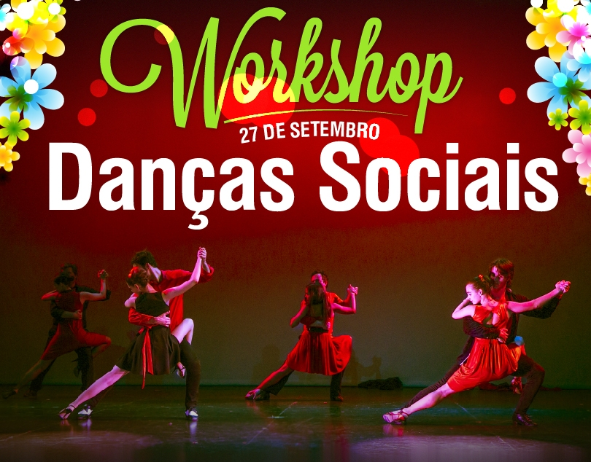

O GDC Fidelidade organiza um Workshop de Danças Sociais para adultos, no dia **27 de Setembro** (Sábado), das 15h00 às 16h30, nas instalações da Dance Spot, na Rua Fernando Vaz nº 10 B, 1750-108 Lisboa.

Esta iniciativa é **gratuita** e exclusiva aos sócios do GDC Fidelidade.

Neste dia serão apresentados vários tipos de dança, tais como: Salsa, Kizomba, Tango e Danças de Salão.

Para além, do Workshop o GDC propõe aos seus associados aulas de Dança de Salão que se realizarão no mesmo local (pelo menos até ao mês de Dezembro de 2014).

As aulas serão de 90 minutos e vão decorrer aos sábados, das 14h30 às 16h00. O valor mensal a cargo do associado será de 15,00€.

Para se inscrever basta enviar a inscrição para o email: [grupo.desportivo.reservas@fidelidade.pt](mailto:grupo.desportivo.reservas@fidelidade.pt)